
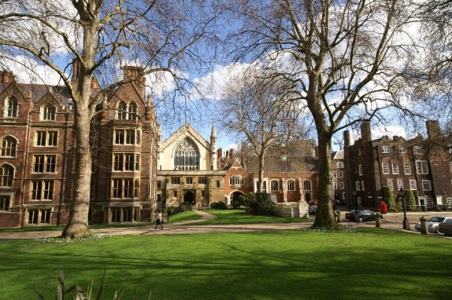

Application: for Filming and Photography.

This form is to be completed and signed before any filming is permitted on the Honourable Society’s Lincolns Inn’s, private property (owned by its members).

Please complete this form in black ink using block capitals and return by post or email (to: murray.campbell@lincolnsinn.org.uk) with proof of public liability insurance to the Assistant Under Treasurer’s Department Where there is not enough room to fully detail the requested information, please use additional sheets of paper and mark this accordingly on the form.

APPLICANT:

Company Name: ……………………………………………………………………..

Address:………………………………………………………………………………..

………………………….……………………………………………………………….

Telephone No……………………..Mobile No………………Fax No………………

email……………………………………………………………………………………

Contact Name……………………Position…………………………………………..

Company status (sole trader, partnership, limited company)........................................

PLEASE PROVIDE:
a) Public Liability document
b) Site specific risk assessment and method statement

TYPE OF FILM: (Please circle as appropriate)
Film / TV / Commercial / Promo / Shorts / Student / Stills / Other:

.....................................................................................................................................................

PRODUCTION TITLE:…………………………………………………………….....

DESCRIPTION OF FILMING/ PHOTOGRAPHY / RECORDING: (i.e: interior /
exterior, what scenes involve)

…………………………………………………………………………………………..

…………………………………………………………………………………………..

LOCATION(S)

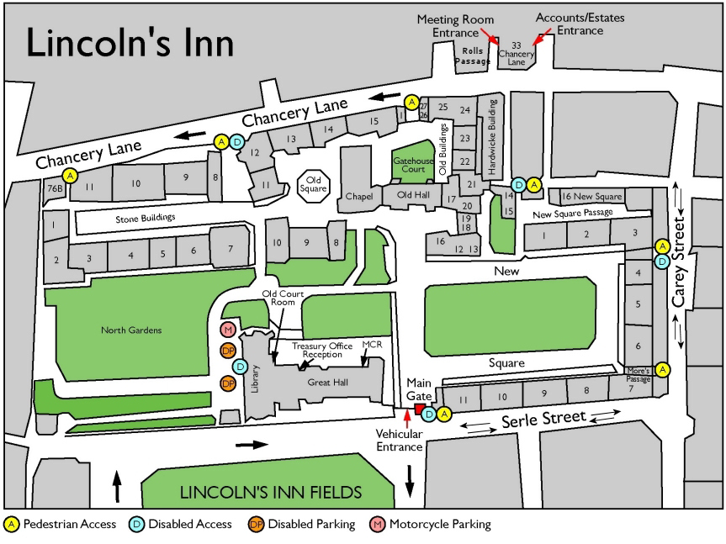
Lincoln’s Inn Chapel / Undercroft 
The Old Hall  limited availability
The Great Hall  limited availability
The Old Court Room  limited availability, and not available before
May 2019
New Square 
Stone Buildings 
Old Square 
North Gardens  not available before May 2019

Permission is normally only given for filming at weekends and sometimes during legal vacations. Filming or photography is not permitted in the library. It may be permitted in other interior spaces depending on availability and other factors.

STILL PHOTOGRAPHS NATURE, PURPOSE AND USE:

…………………………………………………………………………………………..

…………………………………………………………………………………………..

PRODUCER:………………………………………………………………………….

DISTRIBUTION:

Where will the film/photography be distributed: ……………………………………………

Distributor:……………………………………………………………………………….

LOCATION MANAGER:…………………………………………………………….

DETAILS OF ACCESS:
Dates: from…………………….to……………………………………....

Times: from…………………….to………………………………………

No of crew:…………………………………………………………………………….

No of extras: …………………………….…………………………………………….

PARKING REQUIREMENTS: No. and type (s) of Vehicles

…………………………………………………………………………………………

………………….………………………………………………………………………

…………………………………………………………………………………………

…………………………………………………………………………………………

DRESSING ROOM REQUIRMENTS: How many rooms, do you require catering rooms?

……………………………………………………………………………………………………………

……………………………………………………………………………………………………………

……………………………………………………………………………………………………………

Please tick if your shoot may involve any of the following:

Temporary traffic Control 
Street dressing/disguising street markings 
Hand held camera 
Cherry Pickers 
Camera Crane 
Camera Track 
Low Loaders 
Generator 
SFX 
Gunfire 
Pyrotechnics 
Fire Effects 
Reconstruction of crime /emergency 
Animals 
Scaffolding 
Lighting Tower 
Building Blackout 
Crowd Control / security 
Stunts 
Wet Down 
Playback 
Children 

If you have ticked any of the above, or if you have any other equipment
over and above just a camera and tripod, please give details:

……………………………………………………………………………………………………………

……………………………………………………………………………………………………………

……………………………………………………………………………………………………………

……………………………………………………………………………………………………………

……………………………………………………………………………………………………………

……………………………………………………………………………………………………………

……………………………………………………………………………………………………………

……………………………………………………………………………………………………………

……………………………………………………………………………………………………………

……………………………………………………………………………………………………………

……………………………………………………………………………………………………………

……………………………………………………………………………………………………………

POWER SUPPLY REQUIRED:

……………………………………………………………………………………………………………

……………………………………………………………………………………………………………

PROPOSED DATE FOR TECHNICAL RECCE OF LOCATIONS:

…………………………………………………………………………………………………………….

…………………………………………………………………………………………..

