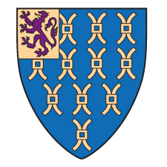
Merchandise Price List
Please note the products below are available either at Reception or the Library. Selected products are available for purchase at our Online shop.
Item | Price
A Lincoln’s Inn Commonplace book | £35.00
The Chapels of Lincoln’s Inn booklet | £5.00
LIBLA cookbook | £5.00
An Introduction to Lincoln’s Inn booklet | £3.50
Inns of Court postcards | £3.00
Lincoln's Inn Postcard – Jinnah, Library, Undercroft | 0.70 each or 5 for £3
Lincoln’s Inn Umbrella | £14.50
Lincoln's Inn Shield Cufflinks | £34.00
Lincoln's Inn Lapel pin | £9.00
Lincoln's Inn Tie | £34.00
Lincoln's Inn Crystal tumblers | £77.00
Lincoln's Inn Pen | £30.00
Lincoln's Inn large Teapot | £20.00
Lincoln's Inn small Teapot | £10.00
Lincoln’s Inn mug | £9.00
Christmas at Lincoln's Inn CD | £5.00
Lincoln's Inn Christmas cards 2019 | 1 pack for £5.50 or 2 packs for £10.00

