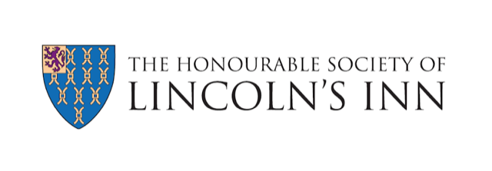
JUNIOR MEMBERS’ COMMITTEE APPLICATION FORM 2020
(A SUB-COMMITTEE OF THE BAR REPRESENTATION COMMITTEE)

Name
Email Address

Year of Call
Chambers/Employer
Area(s) of Practice
Circuit
Why do you want to join the Lincoln’s Inn Junior Members’ Committee? (500 words max.)
Please suggest one event/idea that you consider would be beneficial for the Lincoln’s Inn Junior Members’ Committee to organise/implement and explain why you consider this event/idea would be beneficial to junior members. (500 words max.)

Please return the filled in form to brc@lincolnsinn.org.uk

