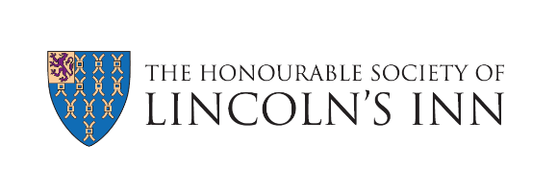

Member Communications Preferences

Please use the form below to indicate which communications you would like to receive from Lincoln’s Inn. Completed forms should be emailed to communications@lincolnsinn.org.uk. Unless otherwise specified, all communications will be sent by email.

First Name
Surname
Date of Birth
Call Date (if known)
Member Number (if known)
Email Address
Phone Number

I wish to receive:
ALL Communications ☐
Monthly Members’ Newsletter ☐
Annual Review – by post ☐
Annual Review – by email ☐
Social / Networking Events ☐
Educational Events ☐
Information from Inn-affiliated organisations
(e.g. other Inns of Court, regulatory bodies, Specialist Bar Associations) ☐

Alternatively, if you wish to opt out from all email communications from Lincoln’s Inn, please check this box: ☐

Date:

You can update these preferences at any time by emailing communications@lincolnsinn.org.uk.
Your data security is important to us. To find out how we use your data, please refer to our Data Protection Policy.

