Process for Joining the Inn as a Student Member
Please read this guidance in full before applying
Admissions are now run through our new Online Admission Portal. If you have any questions during the application process, please email registry@lincolnsinn.org.uk. Below guides you through registering on the new portal.
Please do not register more than once with different email addresses.
1. Head to the portal at https://portal.lincolnsinn.org.uk/my-profile.html
2. Click on ‘Join the Inn’
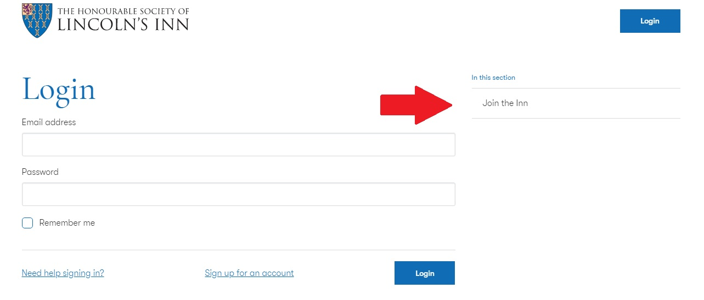
3. Click on ‘Register for an account’
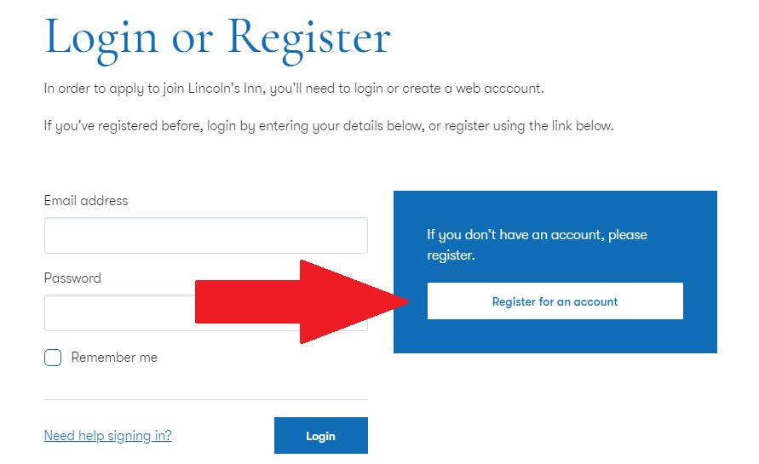
4. Complete the registration form and hit next. A verification code will be sent to you.
5. Enter your verification code to activate your profile
6. From your portal homescreen, click ‘Apply Online’
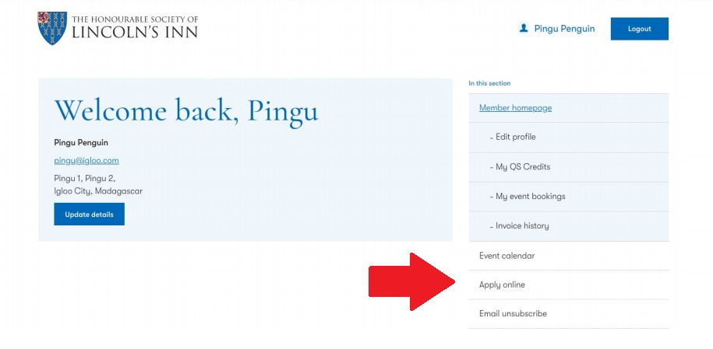
7. Complete the ten steps of the online application form
8. Once completed, download the Application PDF. If you have trouble doing this, please email registry@lincolnsinn.org.uk
9. Collate the following documents and send them by post to the address below:

• Downloaded admission documents (Please ensure these contain your original ink signature)
• A certified copy of your ID (Eg. Passport). Please see the last page of this guidance document
• Certified copy of your law degree / GDL certificate if you have graduated or official confirmation from your university that you are pursuing a Law degree or are enrolled on a GDL course. Please do not send original copies of degree certificates of ID. Please see the last page of this guidance document

REGISTRAR AND ADMISSIONS
THE TREASURY OFFICE
THE HONOURABLE SOCIETY OF LINCOLN’S INN
LINCOLN’S INN
LONDON
WC2A 3TL

Please note that we are unable to accept documents via email.

10. Once documents arrive, we aim to review these within fifteen working days. Upon approval, a link to complete the admission payment online will be sent to you via email.

CERTIFIED COPY GUIDANCE
Applicants to the Inn need to provide a certified copy of photo identification (“photo ID”) and degree certificates if awarded. Acceptable forms of photo ID are:

• Current signed passport
• Current full UK or EEA photocard driving licence
• National identity card bearing a photograph of the applicant

Those applying for student admission to the Inn (ie Future Bar Course students) who have completed their law degree / GDL need to provide a certified copy of their degree certificate.

You must not send your original photo ID or degree certificate by post as we will not be responsible for its safe return to you.

Who can certify a document?

Your document must be certified by a professional person or someone well-respected in your community (‘of good standing’). You could ask the following if they offer this service:

• bank or building society official
• councillor
• minister of religion
• dentist
• chartered accountant
• solicitor or notary
• teacher or lecturer
• post office

The person you ask must not be:

• related to you
• living at the same address
• in a relationship with you

The Post Office also offer a document certification service.

How to certify a document

Take a photocopy of your photo ID and then take the copy and the original and ask the person to certify the copy by:

• writing ‘Certified to be a true copy of the original seen by me’ on the document
• signing and dating it
• printing their name under the signature
• adding their occupation, address and telephone number

The person certifying the document may charge you a fee.

