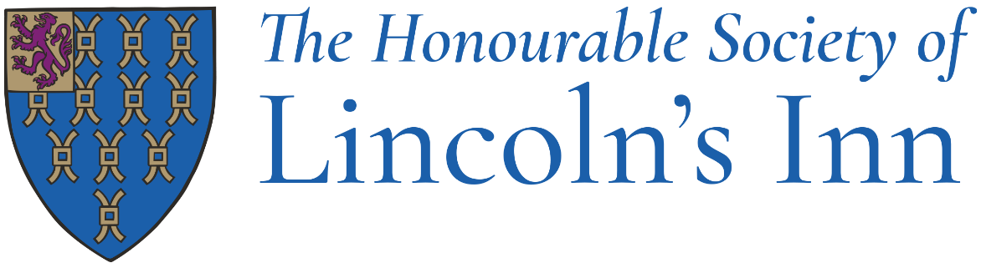

Lincoln’s Inn Remote Interviewing
Lincoln’s Inn holds Bar Course Scholarship interviews in London, Birmingham, and Manchester. GDL Scholarship interviews are held in London only. The most effective way for the interview panel to assess a candidate is through an in-person interview and the Inn encourages all candidates to attend an in-person interview if they are reasonably able to do so.
Should a candidate not be able to attend an interview in person, it is possible for them to be interviewed remotely via video conferencing software. Remote interviews will only be arranged for good reason. Examples include but are not limited to:
- Candidate is currently studying/living abroad.
- Candidate has physical difficulty travelling to one of the interview locations.
- Candidate has financial difficulty travelling to one of the interview locations.
If a candidate feels that they need to be interviewed remotely they will need to contact Scholarships@lincolnsinn.org.uk to check that they are eligible, and arrangements can then be made.
Remote interviews will be conducted by panels who will also conduct face-to-face interviews. They will take place on the same day as the face-to-face interviews.

