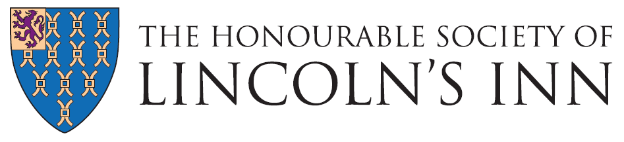

Job Title: Hospitality Assistant

Department: Catering

Reporting to: Supervisors/ Event Operations Manager

Responsible for: Agency staff where required

Post Objectives
To assist in the Front of house services across the Inn, serving food and beverages to the highest possible standards in accordance with the Inns policies and in accordance with Food and Health and Safety legislation.

Main Duties
The following list of duties is indicative of the nature of the post. Priorities, time-scales and standards will be set in agreement with management, recognising the level of professional competence of the post-holder.

- To be responsible for the service of food and beverages within areas of the Inn to both internal and external clients.
- To prepare and serve beverages and accompaniments in accordance with the event sheets.
- To prepare and set mise-en-place for lunch, events and meetings as directed.
- To assist in room and audio visual meeting and conference set ups.
- To clear and clean front of house equipment and store in a safe and secure manner.
- To competently advise guests on menu details and allergens as instructed by the duty chef.
- Complete all relevant Front of House (FOH) cleaning schedules in relation to the area of work on a daily basis.
- To maintain a “Can Do” attitude and assist other colleagues across the department when asked.
- Maintain a professional and respectful manner to guests and colleagues at all times.
- Serve within the MCR Restaurant when required at Breakfast, Lunch or dinner.

Occasional Duties
- To attend training courses and departmental meetings as required.
- Undertake other duties, within reasonable request of management.

Person Specification

Job Title: Hospitality Assistant

Department: Catering

Skills, knowledge & attitude required

- You will be able to demonstrate knowledge of the catering industry and have at least 1 year of previous experience, ideally in a unique venue.

- You will be flexible in your approach to work and be willing to adapt to changing circumstances.

- You will demonstrate honesty and integrity in everything you do.

- As the successful candidate you are expected to adhere to the following values:

- You will work with your colleagues, to bring the best out in each other and form a great team.

- You will recognise and respect we are all different, have different values and experiences.

- You will be proud to work at Honourable Society of Lincoln’s Inn and you will always positively promote the Inn’s values.

- You will work hard and be positive in all you do and use your initiative. You will turn each challenge into a positive result.

- You will want to be the best in all you do, always aiming to improve your skills. You will continue to aim for the highest standard of service and ensure you and your colleagues go the extra mile.

