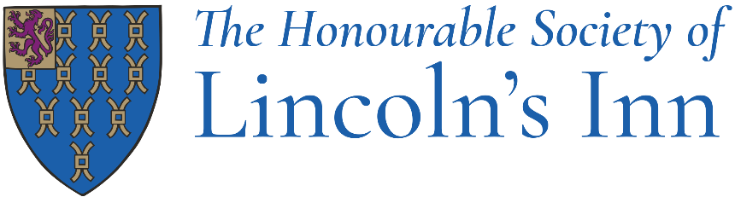

Job Title: Head of Sales and Events (Maternity Cover - Fixed Term)

Department: Events office, Catering department

Reporting to: Head of Catering

Responsible for: The external events team
Member events
Business development

Post Objectives
Nurture a team of event professionals within a busy office setting. Implement and execute successful strategies to include planning activities for both internal and external events. Including a sales strategy to maximise reactive and proactive event sales. Ensure efficient processes for all events driven through the events office are adhered to measured and monitored.

Provide insight and regular report analysis recognising where proactive sales focus may need to change dependant on sales position. Manage relationships and resources to support the appropriate promotive exposure of the Inn showing Lincoln’s Inn as a centre of event and food excellence and a leading venue in London and the UK.

Main Duties
The following list of duties is indicative of the nature of the post. Priorities, time-scales and standards will be set in agreement with management, recognising the level of professional competence of the post-holder.

- To be responsible for managing both the Inn’s events and private events activities
- Manages the Inn’s reactive and proactive sales activities
- Ensure the accuracy of finalised event details prior to distributing/publishing to other Inns departments.
- In consultation with the Head of Catering ensure that event charges, tariff and suppliers’ agreements are adhered to in conjunction with the Hospitality, Events and Dining Committee.
- Lead events team meetings, regular team one to ones, business development meetings and any catering department meeting to distribute event details.
- Oversight of the Inn’s members accommodation (three self-catered one-bedroom flats).
- Engage, lead and inspire the events team with knowledge, training and exposure to activities that will strengthen our event sales proposition.
- Planning menus for internal and external events in conjunction with the Head of Catering and Head Chef.

Sales

- Implement and execute an annual sales & marketing strategy that measures ROI to be incorporated in the department’s budget.

- Set individual and team targets, monitor sales forecasts gearing toward improved sales conversion rates.

- Track weekly, monthly, and yearly catering business forecasts against budget. Respond to low demand periods with innovate promotions to maximise sales.

- Manage and develop supplier partnerships, creating a profitable revenue stream for the events team.

- Complete periodic market research of our competitors. Ensuring we are aware of competition activities and promotions both of price and innovation. Ensure the Inn’s offering is kept relevant, competitive and up to date.

- Plan, co-ordinate and attend external networking events, exhibitions, FAM trips and trade shows.

- Guide and manage the Sales & Events Manager to build solid and productive working relationships with key accounts including agencies, hosting familiarisation trips and attending networking events and client retention.

Marketing

- Create an annual marketing budget with a clear focus on ROI.

- Oversee all marketing activities and approve copy for a range platforms and channels, including social media, digital and printed content, marketing materials, advertisements, newsletters, awards, PR/media and 3rd party listings, ensuring that all are relevant, engaging and comply with the Inn’s visual and digital guidelines.

- Contract and manage external PR and Marketing agency relationships, thus increase Inn’s market awareness and drive sales. Provide direction and guidance to agencies, outlining targets and KPI’s. Host weekly PR meetings to track results against present targets.

- Plan and deliver all relevant marketing campaigns in line with the department’s objectives and routes to potential clients. Continuous analysis and debrief evaluation of marketing campaigns to improve performance.

- Identify new PR opportunities and coordinate activities with media agencies to increase exposure.

- Create marketing and event office materials, including proposals and email templates, ensuring that the event office replies in a professional and efficient manner, whilst maximising sales opportunities.

- Create content to enrol the catering department in to industry leading awards, creating further public awareness and recognition.

- Guide the Member Events Executive to effectively market Inn’s events, using all relevant promotive routes and design tools available.

- Maintenance of the venues event website including regular review of content, images and relevant customer case studies. Provide recommendations and direction for future development of the site.

Team Leadership and Processes

- Manage the efficient and structured day-to-day running of the events office. Measure and monitor the event office team members performance, setting objectives and targets, scheduling regular catch-ups, providing on the job training and developing their skills where needed.

- Ensure that the events office maintain all organisational data relating to events on the rendezvous system, thus having one central location for the event diary, activities, records, financial information and communication.

- Increase events team and departmental efficiency and communication through new system implementation and review.

- Ensure the events office retains great customer relations and service, keeping the highest level of customer satisfaction and retaining and attracting great clientele.

- Be available and prepared to attend functions to fulfil this requirement.

Other

- Create and use spreadsheets for event costings, food and beverage control, when required with the Head of Catering.

- Hospitality, Events and Dining Committee support; attending committee meetings, taking minutes and converting these to the outcome report. Attend, if needed, working groups and development meetings that are relative to the events team.

- To undertake other reasonable duties requested by management, within the level of skill and experience of this post.

Job Title: Head of Sales and Events

Department: Catering

Skills, knowledge & attitude required

- At least 2-3 years’ managerial experience leading a successful professional team of event professionals, ideally within a unique venue or 5* hospitality venue. Generating measurable commercial event sales through planned yield management.

- Marketing strategy and planning experience including planning and delivering multiple marketing campaigns.

- Excellent organisational, negotiating and team leadership skills.

- Proven ability to manage varying workloads under stress and tight deadlines.

- Excellent verbal and written communication skills with the ability to communicate clearly with a wide range of people and organisations.

- Excellent IT skills with MS Office, diary management systems and report writing.

- Good levels of numeracy, sales and profit accountability.

- Willing and able to work unsocial hours when required.

- Be confident and positive toward challenges given. Empowering the team with opportunity and drive to succeed.

- Cultivate great relationships with members of the Inn and staff, promoting the professional behaviour of the events office.

- Possess a keen interest in current fine dining and wine appreciation.

