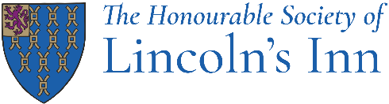

Member Communications Preferences

Please use the form below to indicate which communications you would like to receive from Lincoln’s Inn. Completed forms should be emailed to communications@lincolnsinn.org.uk. Unless otherwise specified, all communications will be sent by email.

First Name
Surname
Date of Birth
Call Date (if known)
Member Number (if known)
Email Address
Phone Number

I wish to receive:
ALL mailings ☐
Members Newsletter (a monthly digest from the Inn) ☐
Inn events (events for members eg Grand Day, dining, lectures etc) ☐
The MCR (promotions, menus, offers eg supper clubs, jazz nights, tastings) ☐
Professional Development / Education (opportunities, news and events) ☐
Chapel ☐

Alternatively, if you wish to opt out from all email communications from Lincoln’s Inn, please check this box: ☐

Date:

You can update these preferences at any time by emailing communications@lincolnsinn.org.uk.
Your data security is important to us. To find out how we use your data, please refer to our Data Protection Policy.

