**CERTIFIED COPIES GUIDANCE**

**WHAT SHOULD BE INCLUDED WITHIN YOUR ADMISSON**

**As a student applicant: -**

* Your signed and dated admission form
* 1 certified identification
* 1 proof of study (If you do not have a degree certificate) **OR** 1 x certified Degree Certificate

**As a TQL applicant: -**

* Your signed and dated admission form
* 1 x certified identification
* Letter from the Bar standards board.

Please make sure there are: -

**X** NO additional documents i.e. previous educational awards, references etc

**X** NO additional copies.

**X** NO photographs.

**WHAT DO WE MEAN BY ‘CERTIFICATION OF DOCUMENTS’?**

As described on GOV.UK certification of documents is - Certify a document as a true copy of the original by getting it signed and dated by a professional person, like a solicitor.

**WHAT DO YOU NEED TO CERTIFY?**

* The copy of your identification i.e. a passport, a driving license or an identification card.
* The copy of your degree certificate

Please **DO NOT** send any additional ID documents or certificates**.**

**YOU DO NOT NEED TO CERTIFY:**

* Your proof of study.
* Your admission form.
* Your Bar standards board letter.

**WHAT DO WE MEAN BY ‘PROOF OF STUDY’?**

If it has been more than 12 months since you completed your Law degree or GDL, you will need to provide a certified copy of your degree certificate.

In some instances, you may still be studying, or you may be due to graduate soon and have not been issued or received your certificate yet. In these circumstances please provide one of the below: -

* A student status letter on headed paper from your university including your full name, course details and estimated completion date.
* Proof of enrolment letter from your university on headed paper including your full name, course details and estimated completion date.
* A transcript from your university on headed paper including your full name, course details and estimated completion date.

We **WILL NOT** accept: -

**X** Registration letters

**X** Email printouts

**X** CAS letters

**HOW TO CERTIFY YOUR DOCUMENT**

Your Degree certificate and/or Identification must be certified by a person of good standing and in a professional position.

The definition of good standing is someone who works in or is retired from a recognised profession. Most individuals who hold positions of professional responsibility are considered a person of standing. Examples include: Registered health and care professionals. Professionals such as lawyers, solicitors, accountants and notaries

The person you ask **MUST NOT** be related to you, live at the same address or be in a relationship with you.

**When certifying your document, they must: -**

1. Write in ink “I certify that this is a true copy of the original seen by me”
2. Sign their name
3. Write their full name in BLOCK CAPITAL LETTERS
4. Write their job title
5. Write their full address
6. Write their direct number
7. Write their direct email address

If any of the steps are missed, we **CANNOT** process your application and we will contact you asking you to provide the correctly certified documents.

Please make sure your documents have: -

**X** NO STAMPS

**X** NO STICKERS

**X** NO “ATTESTED BY”

**OTHER WAYS TO CERTIFY YOUR DOCUMENTS IF YOU ARE BASED IN THE UK**

The UK Post Office document certification service. This is a charged service. They **WILL NOT** certify it as advised above, but their certification **IS** accepted by us.

**\*\* Please see page 4 and 5 for an example of how your certification should look. \*\***

Example of Identification certification.

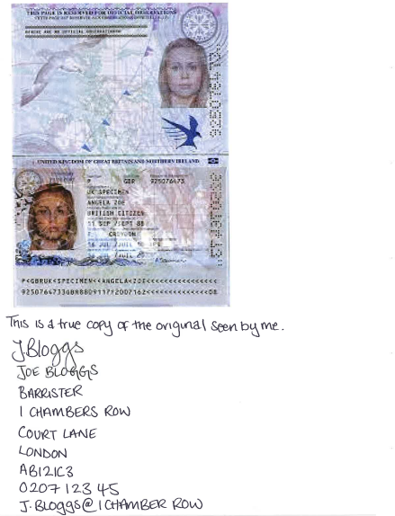

Example of Degree certification

