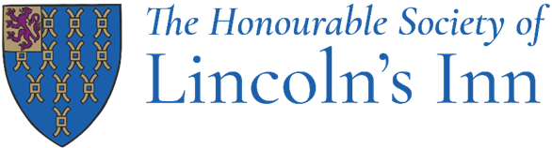

Job Title: Sales & Events Executive

Department: Catering

Reporting to: Sales & Events Manager
Head of Sales & Events

Responsible for: Not applicable

How to apply: Please send your CV and covering letter to HR@lincolnsinn.org.uk

Post Objectives

To assist the Sales & Events Manager and Head of Sales & Events in converting commercial events enquiries into profitable business, coordinating all aspects of events with clients, suppliers and Inn’s staff, assist in business development and delivery of sales strategies.

Main Duties

The following list of duties is indicative of the nature of the post. Priorities, time-scales and standards will be set in agreement with management, recognising the level of professional competence of the post-holder.

Event Planning and Management:

- Assist in achieving the team’s annual income targets by providing sales support, answering email and telephone enquiries, conducting show-rounds with potential clients, and converting enquiries to confirmed events.

- Finalising requirements and event details with clients. Liaising with contacts and Inn’s departments ensuring event details are captured and communicated accurately.

- Sell, plan and coordinate both small and large-scale events, ensuring individual KPIs and team targets are met and the events diary system is used effectively.

- Act as a key point of contact for clients, coordinating communication between internal departments, suppliers and contractors to ensure smooth event delivery.

- Demonstrate a strong focus on maximising revenue by following yield management and upselling strategies where appropriate.

- Maintain and strengthen existing client relationships increasing revenue wherever possible.

Sales and Marketing:

- Proactively seek new business opportunities and support managers in developing new revenue streams.

- Attend exhibitions, trade shows, agency events and develop relationships with organisers and event planners.

- When required work with the managers to assist with marketing initiatives

- Seek, develop and maintain key accounts and maximise the external revenue potential.

Finance:

- Ensure all invoices are sent and paid as per the contract, supporting the accounts department when required.

- Maintain awareness of event sales budgets and support the team in meeting or exceeding revenue targets.

Administration:

- Ensure all event administrative duties such as contracts, deposits, final invoicing etc, are completed according to set standards and timelines.
- Liaising with contacts and Inn’s departments ensuring event details are captured and communicated accurately.

- Where necessary, assist other team members with administrative tasks.

- To undertake any other duties which are commensurate with the level of skill and experience required for this post.

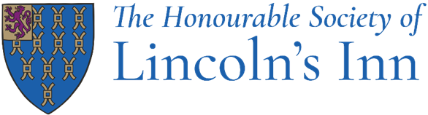

Job Title: Sales & Events Executive

Department: Catering

Skills, knowledge & attitude required

- Proven relevant experience in event sales and management in a venue. You will be able to demonstrate knowledge of the events and catering industry and have at least 2 years of previous event and marketing experience of a role at this level, ideally in a unique venue.

- Strong understanding of event processes, logistics and operations within a historic venue and the ability adapt where necessary to handle unforeseen challenges.

- Excellent negotiation and communication skills.

- A positive attitude and a customer focus to your work, a professional and courteous representative of the Inn dealing with various private and commercial clients and prominent senior figures within the legal community.

- Experience of using an online booking database, preferably rendezvous as well as Word, Excel and Outlook.

- Excellent planning skills, showing good organisational and event co-ordination skills.

- Excellent teamwork and communication skills, dealing with different departments and stakeholders, working with colleagues as a team on a consistent long-term basis.

- Good numeracy skills with the ability to deal with some accounting queries.

- Flexibility in approach to work and willing to adapt to changing circumstances.

- Honesty and integrity in everything you do.

As a successful candidate:

You will work with your colleagues, to bring the best out in each other and form a great team.

You will recognise and respect we are all different, have different values and experiences.

You will be proud to work at the Honourable Society of Lincoln’s Inn and you will always positively promote the Inn’s values.

You will work hard and be positive in all you do and use your initiative. You will turn each challenge into a positive result.

You will want to be the best in all you do, always aiming to improve your skills. You will continue to aim for the highest standard of service and ensure you and your colleagues go the extra mile.

On application, please outline how your experience and personal attributes will align to the above job description and requirements.

Benefits

What’s in it for you:
- A 40-hour contract including paid breaks
- Overtime paid in operational roles
- Great annual training and continual development support
- Team building days
- Generous annual leave entitlement: 30+ days including closure periods over Christmas, Easter and August
- An excellent free lunch
- A non-contributory 12.5% Stakeholder Pension Scheme
- Private Medical Insurance, on completion of probation
- Interest-free season ticket/bicycle loan
- Free uniform for operational roles (laundered)
- Free eye tests and free chiropody
- Employment membership shopping discounts
- Access to a confidential Employment Assistance Programme
- Bicycle storage and shower facilities
- Plenty of social events, such as staff parties, quiz nights etc.
- Enhanced maternity, paternity and shared parental leave
- Death in service benefit, 6 x your annual salary

The Honourable Society of Lincoln’s Inn is committed to ensuring both its members and staff members are treated with dignity and respect throughout their careers. We promote trust, transparency, and respect for all through robust policies and procedures.

