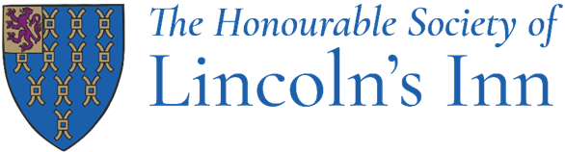

Job Title: Desktop Support Engineer

Department: IT Department

Reporting to: Head of IT

Hours: Mon-Fri, 09:00-17:00. Hybrid working: 4 days in the office and 1 day working from home depending on business needs.

How to apply: Please send your CV to HR@lincolnsinn.org.uk

Post Objectives

To provide technical assistance to all employees, maintain the technical infrastructure and work with the Head of IT and help deliver IT projects.

Main Duties

- To provide 2nd line support and 1st line as required to c170 internal users plus external members as necessary
- To ensure the IT support ticketing system is properly maintained and calls, as well as users, are updated daily and actioned in accordance with agreed timescales.
- To pick up incidents, investigate the root cause and follow their life cycle through to resolution.
- To follow up on escalations/issues where required.
- To support with technical Infrastructure issues and maintenance of server, storage, network and security functionality to ensure safe, reliable and continued service.
- To liaise with 3rd party suppliers regarding application support matters.
- To perform daily checks & a variety of support tasks within the support team.
- To create and keep updated documentation and processes for system implementations as well as user guides.
- To provide guidance and knowledge to colleagues who need support and assistance.
- To build, repair and update virtual and physical machines, as needed.

Person Specifications

Skills/knowledge required:
- A minimum of 2 years' successful hands-on experience working in an IT support environment;
  - Windows OS, IOS, Android, GPO, ADFS, DNS/DHCP, File & Print
  - Microsoft 365 – Exchange Online, Teams, SharePoint, Intune
  - Entra ID
  - Intune, Defender for Endpoint, autopilot
  - Virtualisation Technologies - VMWare or Hyper-V
  - Networking knowledge (WAN, LAN, VLAN, WLAN))

- Willing to work occasionally out of hours when it is required.
- ITIL familiarity
- Professional, highly literate and numerate with excellent analytical skills
- Excellent communication, interpersonal and customer service skills
- Ability to manage time across multiple complex IT projects and daily support duties
- Well-developed interpersonal skills required to establish and maintain effective working relationships and to work well in a team.
- Ability to be flexible, use own initiative, solve problems, and prioritise a busy workload with competing priorities with minimum supervision.
- Able to demonstrate honesty and integrity in everything you do.

Desirable:
- Meraki Experience / Certifications
- Microsoft Server Certifications
- SonicWALL experience
- Microsoft 365 Certifications
- Mimecast experience

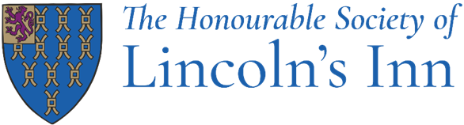

Benefits

What's in it for you?

There are lots of great reasons to work at Lincoln's Inn, including:

- A 40 hour working week including paid breaks
- Generous annual leave entitlement; 30+ days including closure periods over Christmas, Easter
- A non-contributory 12% Stakeholder Pension Scheme
- An excellent free lunch
- Hybrid working, this role will require at least 4 days onsite, central London
- Paid overtime or TOIL given for additional hours worked
- Private Medical Insurance
- Interest-free Season Ticket/Bicycle loan
- Enhanced Maternity and Paternity and Shared Parental Leave
- Great annual training and continual development support
- Bicycle stands and shower facilities
- Death in Service benefit; 6 x your annual salary
- Free Eye tests and free chiropody
- Access to a confidential Employment Assistance Programme
- Team building days
- Plenty of social events, such as staff parties, quiz nights etc.
- Employment Membership shopping discounts

The Honourable Society of Lincoln's Inn is committed to ensuring both its members and staff members are treated with dignity and respect throughout their careers. We promote values of trust, transparency, and respect for all through robust policies and procedures.

