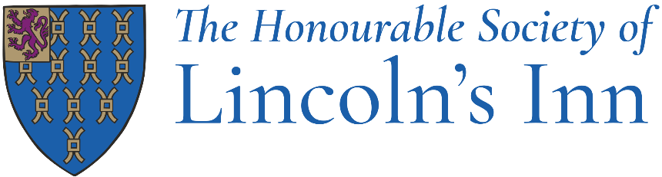
Job Title: Member Services Manager

Department: Membership and Education

Reporting to: Head of Membership

Responsible for: Registry Assistant

Hours: 40 hours per week including 1 hour lunch, Mon-Fri, 9-5
Hybrid working: 3 days in the office and 2 days working from home depending on business needs.

How to apply: Please send your CV and cover letter to HR@lincolnsinn.org.uk.

Post Objectives

To manage the delivery and continuous improvement of member services and systems, ensuring an excellent experience for members, applicants and prospective barristers. The role is responsible for overseeing key membership processes, maintaining accurate membership records and data, leading the successful delivery of the Inn's Call to the Bar, managing regulatory administration and service standards.

Main Duties

The following list of duties is indicative of the nature of the post. Priorities, timescales and standards will be set in agreement with management, recognising the level of professional competence of the post-holder.

Member Services and Systems
- Manage the delivery of responsive, high-quality member services for applicants, students, pupils and barristers.
- Act as the primary escalation point for complex membership enquiries and cases.
- Oversee admissions, membership payments, refunds and related documentation, ensuring compliance with Bar regulations and procedures.
- Maintain accurate and compliant membership records, including members' professional status, appointments and honours.
- Manage and maintain membership data, CRM processes and reporting, working closely with the CRM Administrator to improve system functionality and user experience.
- Produce reports and insights on membership activity, trends and performance.

Call to the Bar
- Develop and manage application processes and operational plans to support all Call-related activities.
- Oversee eligibility checks, regulatory requirements and supporting documentation, including criminal records checks where required.
- Plan and deliver eight Call ceremonies each year, coordinating activity across departments and external suppliers, resolving issues and ensuring a high-quality experience for members and attendees.

Member Conduct
- Oversee the administration of member conduct and disciplinary processes, ensuring accurate record-keeping and timely action.
- Produce documentation and correspondence relating to regulatory and disciplinary matters as required.

Management and Teamwork
- Manage the Registry Assistant, setting clear objectives and performance standards, monitoring performance, conducting appraisals, and supporting ongoing professional development.
- Drive continuous improvement across member services, systems and processes, ensuring high service standards, operational efficiency and regulatory compliance.
- Maintain a reasonable knowledge of the general duties undertaken across the Membership and Education Department.
- Attend events both at the Inn and outside of London for which the post-holder is either solely or jointly responsible to ensure their smooth running as required which will require evening / weekend working for which Time Off In Lieu (TOIL) will be awarded. Some events may involve travelling nationally. The amount of weekend and evening working and travel required will vary throughout the year.

Person Specification

Job Title: Member Services Manager

Department: Membership & Education

Criteria
- At least 3 years' experience delivering high-quality customer, membership or administrative services.

- Experience within a membership organisation, professional body, charity or education/training environment.

- Experience of database maintenance, CRM systems and record keeping.

- Experience of planning and coordinating events, programmes or operational activities involving multiple stakeholders.

- Experience of producing reports, analysing data and using insights to support decision-making and service improvement.

- Experience of supervising or managing a member of staff.

- An undergraduate degree in any subject would be preferable.

- Ability to build productive working relationships and deliver a professional service to colleagues, members, applicants and external stakeholders.

- Excellent written and verbal communication skills, with the ability to communicate effectively with a wide range of people.

- Ability to use initiative, make sound decisions and manage competing priorities.

- Strong organisational and planning skills, with the ability to meet deadlines and maintain high standards of accuracy.

- Proficient in Microsoft Office applications and CRM/database systems, including Word, Excel and Outlook.

- Highly detail-oriented, with experience of improving processes to increase efficiency and support effective service delivery.

- High levels of professionalism, integrity and a positive, proactive approach.

- Able to be flexible and adapt successfully to changing circumstances and business demands.
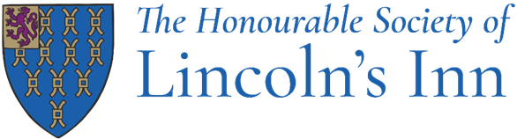

Benefits

What's in it for you?
There are lots of great reasons to work at Lincoln's Inn, including:
- Generous annual leave entitlement; 30+ days including closure periods over Christmas, Easter and August (for most roles)
- An excellent free lunch
- A 35-hour working week including paid breaks (for most roles)
- Hybrid working (depending on role)
- Overtime paid for Operational roles
- Private Medical Insurance
- A non-contributory 12.5% Stakeholder Pension Scheme
- Interest-free Season Ticket/Bicycle loan
- Free uniform for operational roles (laundered)
- Enhanced Maternity and Paternity and Shared Parental Leave
- Great annual training and continual development support
- Bicycle stands and shower facilities
- Great annual training and continual development support
- Death in Service benefit; 6 x your annual salary
- Free Eye tests and free chiropody
- Access to a confidential Employment Assistance Programme
- Team building days
- Plenty of social events, such as staff parties, quiz nights etc.
- Employment Membership shopping discounts
The Honourable Society of Lincoln's Inn is committed to ensuring both its members and staff members are treated with dignity and respect throughout their careers. We promote values of trust, transparency, and respect for all through robust policies and procedures.

