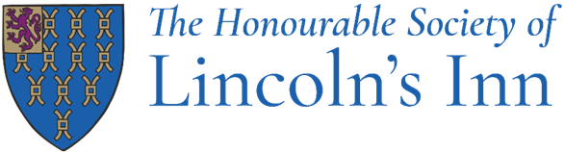

Job Title: Sales and Events Coordinator (Maternity Cover)

Department: Catering

Reporting to: Sales & Events Manager
Head of Sales & Events

Hours: Fixed term- 40 hours per week, Mon-Fri, 9-5

How to apply: Please send your CV to HR@lincolnsinn.org.uk

Post Objectives

To assist the Sales & Events Manager and Head of Sales & Events in converting events enquiries into profitable business, coordinating all aspects of events with clients, suppliers and Inn’s staff and providing clerical and administrative support to the Events Office.

Main Duties

The following list of duties is indicative of the nature of the post. Priorities, timescales and standards will be set in agreement with management, recognising the level of professional competence of the post-holder.

To be responsible for selling, planning and coordinating events including:

Event Planning:

- Assist in achieving the team’s annual income targets by providing sales support answering email and telephone enquiries, conducting show-rounds with potential clients, and converting enquiries to confirmed events.

- Finalising requirements and function details with clients. Liaising with contacts and Inn’s departments ensuring event details are captured and communicated accurately.

- To work in a helpful and professional manner with other departments, members, and clients.

- Sell, plan and coordinate both small and large-scale events, ensuring individual KPIs and team targets are met and the events diary system is used effectively.

- Act as a key point of contact for clients, coordinating communication between internal departments, suppliers and contractors to ensure smooth event delivery.

- Demonstrate a strong focus on maximising revenue by following yield management and upselling strategies where appropriate.

- Maintain, develop and strengthen existing client relationships to ensure repeat business, word of mouth recommendations and increased revenue year-on-year wherever possible.

Sales and Marketing:

- Attend exhibitions, trade shows, agency events and develop relationships with organisers and event planners.

- When required, work with the managers to assist with marketing initiatives for both the events team, and the catering department.

- Seek, develop and maintain key accounts and maximise the external revenue potential.

Finance:

- Ensure all invoices are sent and paid as per the contract, supporting the accounts department when required.

- Maintain awareness of event sales budgets and support the team in meeting or exceeding revenue targets.

Administration:

- Ensure all event administrative duties such as contracts, deposits, final invoicing etc. is completed according to set standards and timelines.
- Liaising with contacts and Inn’s departments ensuring event details are captured and communicated accurately as per the departments guidelines and processes .

- Where necessary, assist other team members with administrative tasks.

- Help the team with organising and updating event collateral

- To undertake any other duties which are commensurate with the level of skill and experience required for this post.

This job description will be subject to review in the light of changing circumstances and may include other duties and responsibilities as may be determined. It is not intended to be rigid or inflexible but should be regarded as providing guidelines within which the individual works.

Person Specification

Job Title: Sales and Events Coordinator
Department: Catering

Skills, knowledge & attitude required

- Proven relevant experience in event sales and management in a venue. You will be able to demonstrate knowledge of the events and catering industry and have at least 2 years of previous event sales and planning experience of a role at this level, ideally in a unique venue.

- You will be IT competent and confident in using databases, Word, Excel and Outlook and diary management systems.

- Excellent negotiation and communication skills.

- You will demonstrate a positive attitude and a customer focus to your work.

- You will be an excellent planner, showing good organisational and event coordination skills.

- You will demonstrate excellent teamwork and communication skills in order to work with your colleagues as a team on a consistent long-term basis

- You will have good numeracy skills with the ability to deal with some accounting queries.

- You will be a professional and courteous representative of the Inn dealing with various private clients and prominent senior figures within the law fraternity.

- You will be flexible in your approach to work and be willing to adapt to changing circumstances.

- Willing and able to work outside working hours when required.

- You will demonstrate enthusiasm to become an active contributor to the team, and the Inn as a whole

- You will demonstrate honesty and integrity in everything you do.

As a successful candidate:

- You will work with your colleagues, to bring the best out in each other and form a great team.
- You will recognise and respect we are all different, have different values and experiences.

- You will be proud to work at Honourable society of Lincoln’s Inn and you will always positively promote the Inn’s values.

- You will work hard and be positive in all you do and use your initiative. You will turn each challenge into a positive result.

- You will want to be the best in all you do, always aiming to improve your skills. You will continue to aim for the highest standard of service and ensure you and your colleagues go the extra mile.

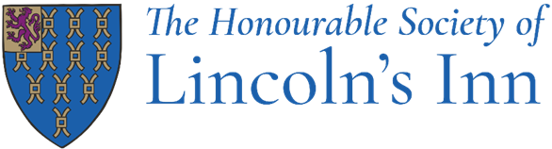

Benefits

What's in it for you?
There are lots of great reasons to work at Lincoln's Inn, including:
- Generous annual leave entitlement; 30+ days including closure periods over Christmas, Easter and August (for most roles)
- An excellent free lunch
- A 35-hour working week including paid breaks (for most roles)
- Hybrid working (depending on role)
- Overtime paid for Operational roles
- Private Medical Insurance
- A non-contributory 12.5% Stakeholder Pension Scheme
- Interest-free Season Ticket/Bicycle loan
- Free uniform for operational roles (laundered)
- Enhanced Maternity and Paternity and Shared Parental Leave
- Great annual training and continual development support
- Bicycle stands and shower facilities
- Great annual training and continual development support
- Death in Service benefit; 6 x your annual salary
- Free Eye tests and free chiropody
- Access to a confidential Employment Assistance Programme
- Team building days
- Plenty of social events, such as staff parties, quiz nights etc.
- Employment Membership shopping discounts
The Honourable Society of Lincoln's Inn is committed to ensuring both its members and staff members are treated with dignity and respect throughout their careers. We promote values of trust, transparency, and respect for all through robust policies and procedures.

